Assignment 4

# Ehsan Emad Marvasti

The objective of the assignment is to reconstruct images from multiple views and motion.

## PART 1

The objective of the assignment is to reconstruct a structure using two different views provided the camera matrix. Once the matches are found the problem of back projection of points on the plain to the world and finding the intersection is solved by triangulation. Due to noise the rays of corresponding points may not intersect. Therefore a triangulation method is required in order to find the best solution. The methods used in the assignment is Linear Triangulation and Optimal algorithm if the noise is considered a Gaussian noise.

### Linear Triangulation

This method relies on the finding the null space of the linear equation system that calculating distance of projection of arbitrary point in 3D from the matches. Null space of this function is the point in world that corresponds to two matching points.

#### Results

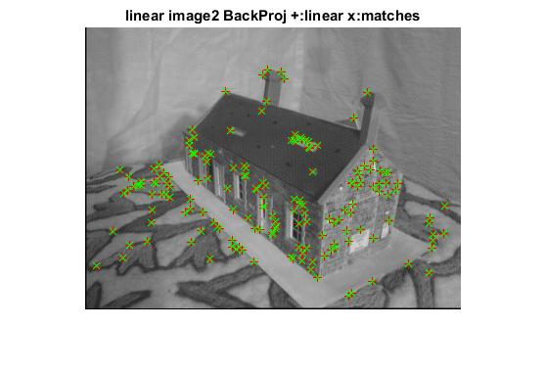Below is the results for the linear triangulation method.

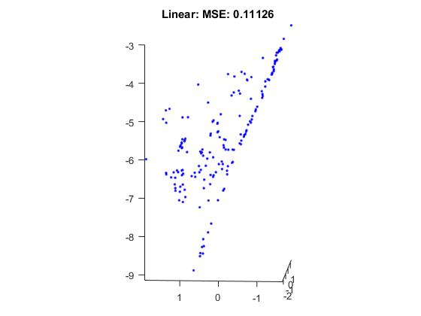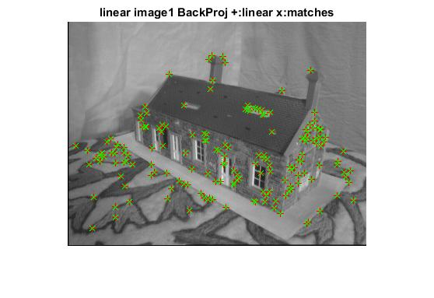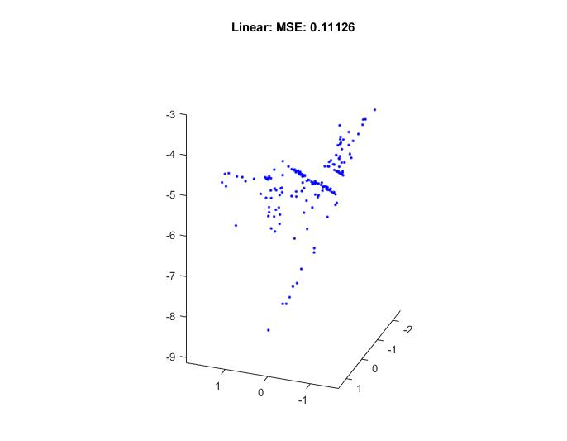

### Optimal Triangulation

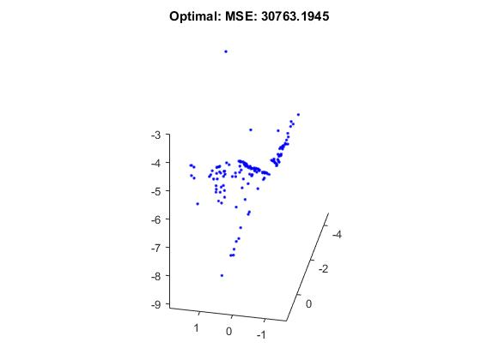This method finds the global minimum of the cost function that is the sum of squared distances assuming the noise is Gaussian. Unfortunately the result I have acquired failed according to some 3 outliers in the result. 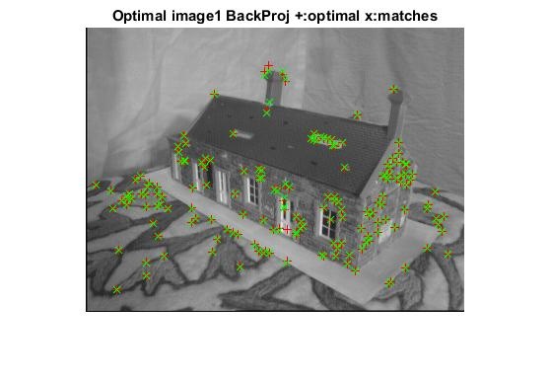

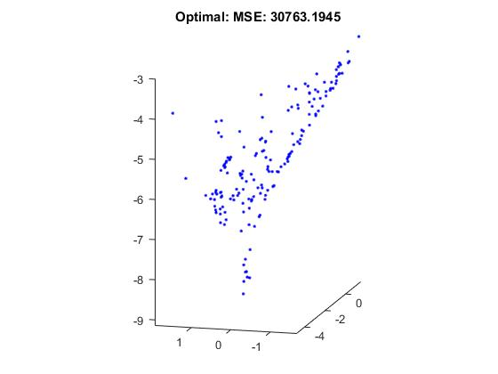

# Structure From Motion

The following is the result of reconstruction.

